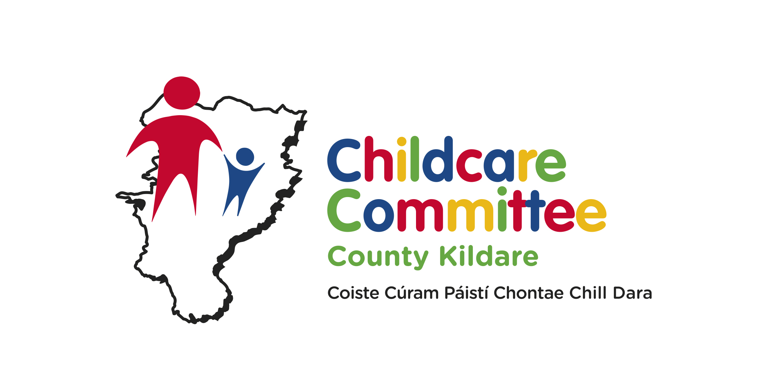

KCCC strives to ensure that early childhood is understood as a significant and distinct time in life that must be valued, nurtured and respected, and that every child in Kildare has equal access to the highest quality education and childcare experiences within their local communities.

KCCC wish to recruit a **Clerical Officer**

**Location of Post:**

KCCCs office is based at Unit 21, Thompson Enterprise Centre, Clane Business Park, Clane, Co. Kildare.

**Clerical Officer**

The ideal candidate should have the following Skills/Experience which are considered essential:

**Eligibility**

**a.** The requisite knowledge, skills and competencies to carry out the role;

**b.** appropriate level and experience of relevant ICT Skills, e.g. proficiency in Word, Excel, e-mail, good reporting writing skills, experience of data entry.

**c.** relevant knowledge and skills to undertake the duties of the position, including the ability to:

* take direction / follow instructions;
* organise and prioritise work effectively;
* work well with colleagues;
* be flexible in their approach to work;
* be able to communicate effectively in a clear and concise manner;

**d.** Full clean drivers licence

**Qualifications**

* ECDL with proficiency in Microsoft suite of programmes including internet and email.

The position of Clerical Officer will be on the basis of 35 hours per week with an immediate start.

A detailed job description is available to download from [www.kccc.ie](http://www.galwaychildcare.com).

Salary scale is aligned to Local Authority Grade 3

The successful candidate will be required to be Garda Vetted.

Application is by CV with cover letter by email to Julie@kccc.ie. Closing date, close of business, Thursday 1st May.

**INTERVIEWS WILL BE HELD 9th May.**

**Kildare County Childcare Committee is an Equal Opportunities Employer**

**______________________**

*All documentation received by Kildare County Childcare Committee in relation to job applications will be processed in accordance with the Data Protection Acts, 1988, 2003 and 2018. The information will only be used by Kildare County Childcare Committee in the processing of job applications and for ongoing administrative purposes with job candidates.  To make a request under the Data Protection Acts, please submit a request in writing to: info@kccc.ie*

